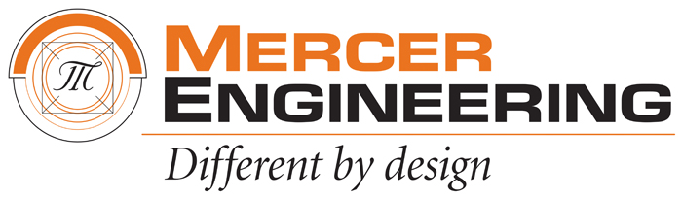

Zachary Cone

SSE 591: Special Topics – Python and Data Science

Table of Contents:

Deliverable Table: 3

Introduction: 4

How to Run Python Code: 5

Basic Python Syntax: 6

Python Semantics: Variables: 7

Python Semantics: Operators: 8

Built-In Scalar Types: 9

Built-In Data Structures: 10

Control Flow Statements: 11

Defining Functions: 12

Errors and Exceptions: 13

Iterators: 14

List Comprehensions: 15

Generators and Generator Expressions: 16

Modules and Packages: 17

Strings and Regular Expressions: 18

Deliverable Table:

|  |  |
| --- | --- |
| Deliverables | Location |
| Introduction |  |
| How to Run Python Code |  |
| Basic Python Syntax |  |
| Python Semantics: Variables |  |
| Python Semantics: Operators |  |
| Built-In Scalar Types |  |
| Built-In Data Structures |  |
| Control Flow Statements |  |
| Defining Functions |  |
| Errors and Exceptions |  |
| Iterators |  |
| List Comprehensions |  |
| Generators and Generator Expressions |  |
| Modules and Packages |  |
| Strings and Regular Expressions |  |

Introduction:

How to Run Python Code:

Basic Python Syntax:

Python Semantics: Variables:

Python Semantics: Operators:

Built-In Scalar Types:

Built-In Data Structures:

Control Flow Statements:

Defining Functions:

Errors and Exceptions:

Iterators:

List Comprehensions:

Generators and Generator Expressions:

Modules and Packages:

Strings and Regular Expressions: